**Chapter 1**

## 

## Introduction

## 1.1 Purpose of the project :

## This project aims at providing people with a platform where they can not only buy cars at a reasonable price but also sell their old cars. The entire project provides the user with an end to end communication with no third party involved.

## 

## 1.2 Motivation:

## The number of cars on the road is increasing day by day which has not only lead to congested roads and increased traffic but also has increased the pollution levels. One solution that can help in control of this problem is checking the number of cars that are being used. With the help of our platform, people will be able to buy used cars which will in turn lead to lesser number of cars on the road. Our platform also provides user to user negotiations thus, preventing any involvement of a third party.

## 

## 1.3 Existing procedure:

## Currently if a person wants to buy a used car then they would have to go through many middle agents who might not provide correct information about the cars. We try to eliminate this issue through our platform.

## Chapter 2

## Project Requirements

**2.1 Software requirement specification:**

A software requirements document is the specification of the system. It includes both a definition and a specification of requirements. It includes functional and non-functional requirements of the software. The Online Car Trade System, allows the admin to view and update user details and allows the registered users to buy and sell cars.

**2.2 Operating System’s Environment:**

**2.2.1 Hardware**

Ø Processor : intel i3 3 GHz, 64 bit processor

Ø Ram : 4 GB RAM

Ø Hard Disk : 50GB

**2.2.2 Software**

Ø Operating System : Windows 10

Ø Programming Language : PHP

Ø Database : MySQL

**2.3 Functional Requirements**

This subsection contains the requirements for the car trade management. These requirements are organized by the features discussed in the purpose and scope of this document. Features from the documents are then refined into use case diagrams to best capture the functional requirements of the system.

**Admin:**

* The application we have developed gives a specific role to the admin.
* He can view all the registered user details.
* He can also view all the cars which are sold or unsold.
* He can register customers.
* Update and remove the users registered.

**User:**

* The user can register by filling the details in the Signup form.
* User can view his profile.
* The user details will be presented when profile is viewed.
* The user can either buy or sell cars.
* If the user decides to buy a car all the cars for sale are displayed in a table.
* User can proceed to buy by clicking the buy button.
* If the user decides to sell a car then all the car details will have to be entered into the given form.

**Generating a bill for the purchased items**.

* On submission, the deal is completed, and the details are updated accordingly.
* An invoice is generated for completed deal.

## 2.4 Non-Functional Requirements

* Security: Each user can decide their username and a password. If wrong password is given the application will pop out a message. The user should be able to change password by providing existing password.
* Reliability: The application should be reliable, and all data should be stored in the database only.
* Modifiability: User should be able to easily modify and update changes in the application without affecting database.
* Usability: Should allow for a user to sell and buy multiple cars.
* Maintainability: Should be easy to maintain. There should be a facility to add, delete or update the users registered.

**Chapter 3**

**Literature Survey**

**3.1 Current Situation:**

Currently there are no efficient platforms for people to buy and sell their used cars. Our platform aims at filling this void. This project will help the users not to only in conveniently choosing cars but also save them from the hassle of going through a third party.

**3.2 Front-end Technology**

**PHP :** PHP (recursive acronym for PHP: Hypertext Preprocessor) is a widely-used open source general-purpose scripting language that is especially suited for web development and can be embedded into HTML.

**JavaScript :** JavaScript is a lightweight, interpreted programming language. It is designed for creating network-centric applications.

**HTML :** Hypertext Markup Language (HTML) is the standard markup language for creating web pages and web applications.

**CSS :** Cascading Style Sheets (CSS) is a simple mechanism for adding style (e.g., fonts, colors, spacing) to Web documents.

**3.3 Database Technology :**

**3.3.1 MySQL**

MySQL is an open source relational database management system (RDBMS) based on

Structured Query Language (SQL). MySQL runs on virtually all platforms, including Linux,

UNIX, and Windows.

**3.3.2 PhpMyAdmin**

phpMyAdmin is a free and open source administration tool for MySQL and MariaDB.

**Chapter 4**

**System Design**

**4.1 Database Design**

The data required for this project is organized and stored as tables in MYSQL database.

The lists of tables in this project are:

* Car : It contains primary details like car id, owner id, type, brand, model, fuel type, transmission type about the car
* Car details : This table stores information about the secondary(physical) attributes of the car such as the car condition, registration no, color, year of purchase, price and the total distance covered by the car
* Car status : This table contains current status of all the cars which are present in the database. The status attribute tells us whether the car has been purchased or not.
* Login info : This table includes username and password used to log in by the user.
* Owner : It is used to register all the user details to create an account. It includes user’s name , user’s phone number , address and email id of the user.
* Security Details : It covers all the security information about the car like insurance number, RTO number and the emission rating.

The Schema (Fig 4.1) depicts the dependencies among the tables

The Entity-Relation Diagram (Fig 4.2) depicts the relations and their corresponding entities.

Data flow diagram(Fig 4.3) depicts the flow of the application.

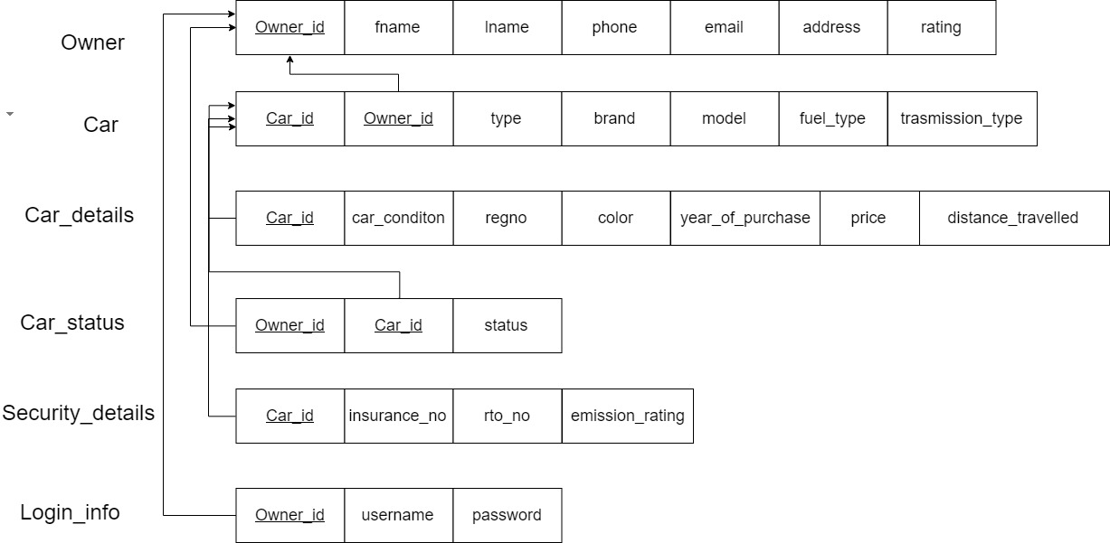

**Figure 4.1 Schema Diagram**

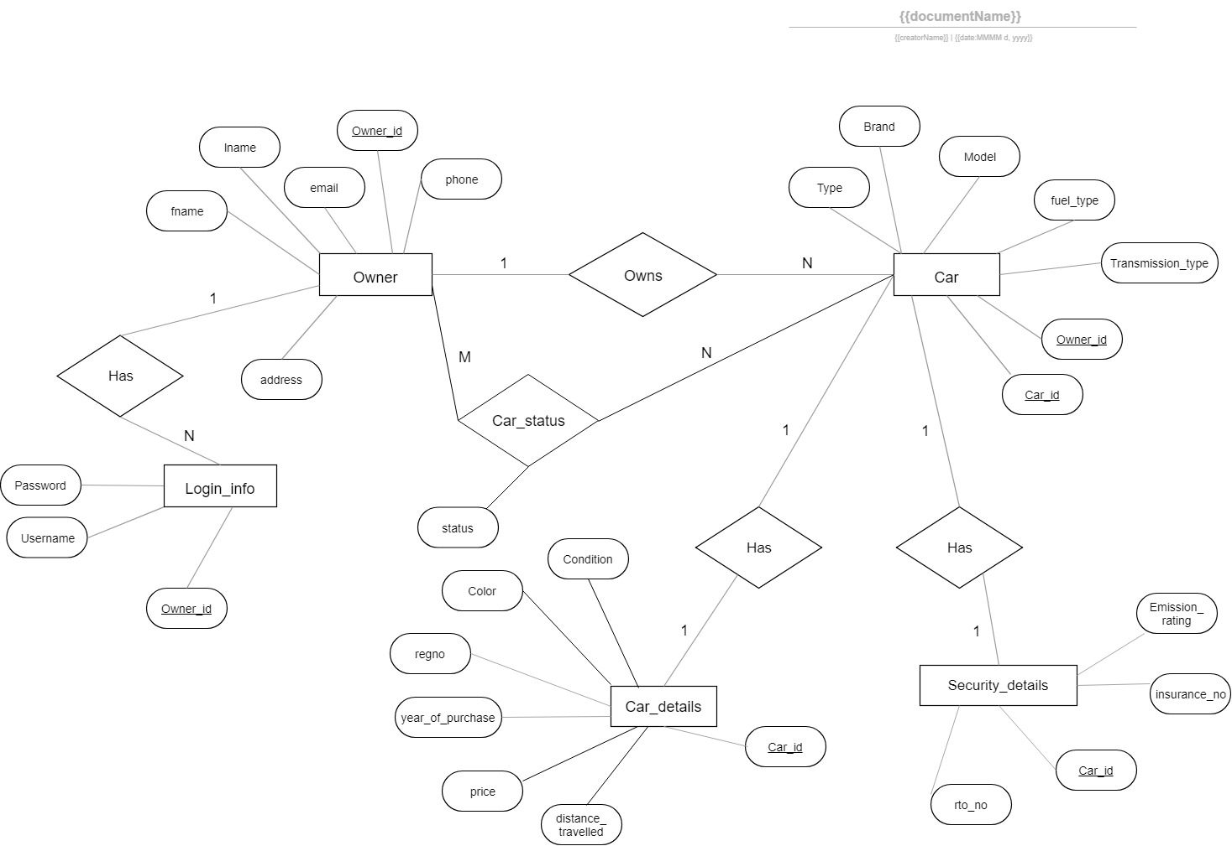

**Figure 4.2 Entity-Relationship Schema**

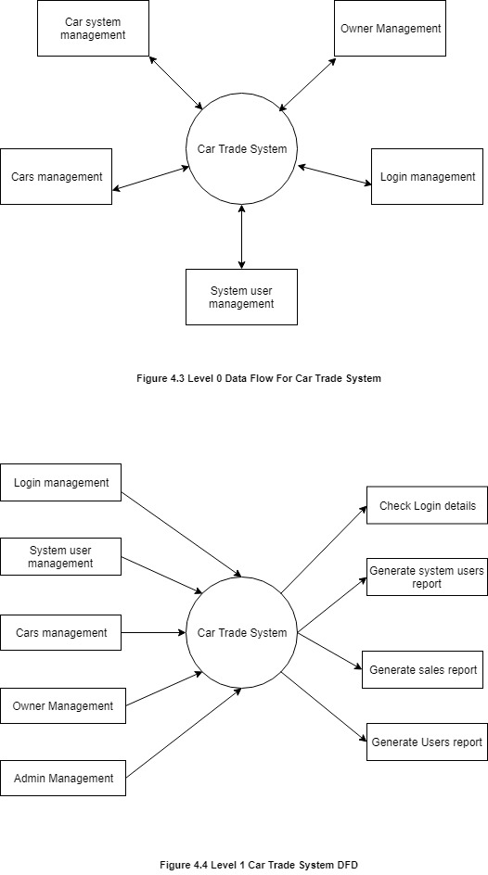

**Chapter 5**

**Implementation**

**5.1 PHP and HTML Code**

**5.1.1 Connecting to the database and User authentication**

//Connection

<?php

$connection = mysqli_connect('localhost', 'root', '','dbms');

if (!$connection){

die("Database Connection Failed" . mysqli_error($connection));

}

$select_db = mysqli_select_db($connection, 'dbms');

if (!$select_db){

die("Database Selection Failed" . mysqli_error($connection));

}

?>

//authentication

<?php session_start(); ?>

<?php require('db_connect.php');

if (isset($_POST['user_id']) and isset($_POST['user_pass'])){

$username = $_POST['user_id'];

$password = $_POST['user_pass'];

// CHECK FOR THE RECORD FROM TABLE

$query = "SELECT * FROM `login_info` WHERE username='$username' and Password='$password'";

$result = mysqli_query($connection, $query) or die(mysqli_error($connection));

$count = mysqli_num_rows($result);

if ($count){

$_SESSION['logged']=true;

$_SESSION['username']=$username;

echo "$username";

header("Location: home2.html");

}

else{

echo " <script type='text/javascript'>alert('Invalid Login Credentials')</script>";

$_SESSION['logged']=false;

header("Location: login2.html");

echo "Invalid Login Credentials";

}

}

?>

**5.1.2 Buying a car**

<?php

// Start the session

session_start();

?>

<!DOCTYPE html>

<html>

<meta name="viewport" content="width=device-width, initial- scale=1">

<link rel="stylesheet" href="https://maxcdn.bootstrapcdn.com/bootstrap/3.3.7/css/b ootstrap.min.css">

<script src="https://ajax.googleapis.com/ajax/libs/jquery/3.3.1/jqu ery.min.js"></script>

<script src="https://maxcdn.bootstrapcdn.com/bootstrap/3.3.7/js/boo tstrap.min.js"></script>

<style>

/* Style the input field */

#myInput {

padding: 20px;

margin-top: -6px;

border: 0;

border-radius: 0;

background: #f1f1f1;

}

</style>

</head>

<body id="body_bg">

<div <div align="center">

<h1>Car Trade</h1>

<hr>

<form action="search1.php" method="POST">

Keyword:<br>

<input type="text" placeholder="Search..." name="Keyword">

<input type="submit" value="Submit">

</form>

</hr>

</div>

<hr>

<div class="container">

<div class="dropdown">

<button class="btn btn-primary dropdown-toggle" type="button" data-toggle="dropdown">Filter

<span class="caret"></span></button>

<ul class="dropdown-menu">

<input class="form-control" id="myInput" type="text" placeholder="Search..">

<li><a href="brand.php">Brand</a></li>

<li><a href="asc.php">Asc Sort</a></li>

<li><a href="desc.php">Desc Sort</a></li>

</ul>

</div>

<script>

$(document).ready(function(){

$("#myInput").on("keyup", function() {

var value = $(this).val().toLowerCase();

$(".dropdown-menu li").filter(function() {

$(this).toggle($(this).text().toLowerCase().indexOf(value) > -1)

});

});

});

</script>

</html>

<?php

include "db_connect.php";

$sql="SELECT * FROM car";

$result = $connection->query($sql);

if ($result->num_rows > 0) {

echo "<br>Results<br><br>";

while($row = $result->fetch_assoc()) {

echo "Type: ". $row["type"]."<br>"."Brand: ".$row["brand"]."<br>"."Model: ".$row["model"]."<br><br>";

}

}

else {

echo "Error: " . $sql . "<br>" . $connection->error;

}

?>

</hr>

**5.1.3 Selling a car**

<!DOCTYPE html>

<html>

<body>

<h1>Car Trade</h1>

<hr>

<form action="insert2.php" method="POST">

Car Type:<br>

<input type="text" name="type"><br><br>

Car brand:<br>

<input type="text" name="brand"><br><br>

Car Model:<br>

<input type="text" name="model"><br><br>

Fuel Type<br>

<select name="ft">

<option value="petrol">petrol</option>

<option value="diesel">diesel</option>

<option value="eco">Eco</option>

</select>

<br><br>

Transmission Type<br>

<select name="tt">

<option value="auto">auto</option>

<option value="manual">manual</option>

</select>

<br><br>

<h2> Enter the details</h2>

Car condition:<br>

<select name="car_cond">

<option value="old">old</option>

<option value="new">new</option>

</select>

<br><br>

Car Color:<br>

<input type="text" name="color"><br><br>

Registration number:<br>

<input type="text" name="reg"><br><br>

Year of purchase:<br>

<input type="txt" name="year"><br><br>

Price(₹):<br>

<input type="text" name="price"><br><br>

Distance Travelled:<br>

<input type="text" name="distance"><br><br>

<h2> Enter the Extra details</h2>

Insurance Number:<br>

<input type="text" name="ino"><br><br>

Rto Number:<br>

<input type="text" name="rto"><br><br>

Emission Ratings:<br>

<input type="txt" name="emi"><br><br>

<input type="submit" value="Submit">

</form>

</hr>

</html>

</body>

**5.2 Database**

**5.2.1 Creation of Tables**

**Table structure for ‘owner’**

**-----------------------------------------------------------------------------------**

CREATE TABLE `owner` (  
 `owner_id` int(3) NOT NULL AUTO_INCREMENT,  
 `fname` varchar(10) NOT NULL,  
 `lname` varchar(10) NOT NULL,  
 `phone` varchar(11) NOT NULL,  
 `email` varchar(30) NOT NULL,  
 `address` varchar(40) NOT NULL,  
 `rating` int(1) DEFAULT NULL,  
 PRIMARY KEY (`owner_id`),  
 UNIQUE KEY `phone` (`phone`)  
) ENGINE=InnoDB AUTO_INCREMENT=11 DEFAULT CHARSET=latin;

**-----------------------------------------------------------------------------------**

**Table structure for ‘login_info’**

**-----------------------------------------------------------------------------------------------**

CREATE TABLE `login_info` (

`owner_id` int(3) NOT NULL,

`username` varchar(20) NOT NULL,

`password` varchar(25) NOT NULL,

UNIQUE KEY `username` (`username`),

KEY `owner_id` (`owner_id`),

CONSTRAINT `login_info_ibfk_1` FOREIGN KEY (`owner_id`) REFERENCES `owner` (`owner_id`) ON DELETE CASCADE ON UPDATE CASCADE

) ENGINE=InnoDB DEFAULT CHARSET=latin1;

**---------------------------------------------------------------------------------------------------------------**

**Table structure for ‘car’**

**-----------------------------------------------------------------------------------**

CREATE TABLE `car` (

`car_id` int(3) NOT NULL AUTO_INCREMENT,

`type` varchar(10) NOT NULL,

`brand` varchar(10) NOT NULL,

`model` varchar(10) NOT NULL,

`fuel_type` varchar(6) NOT NULL,

`transmission_type` varchar(6) NOT NULL,

`owner_id` int(3) NOT NULL,

PRIMARY KEY (`car_id`),

KEY `car_id` (`car_id`),

KEY `owner_id` (`owner_id`),

CONSTRAINT `car_ibfk_1` FOREIGN KEY (`owner_id`) REFERENCES `owner` (`owner_id`) ON DELETE CASCADE ON UPDATE CASCADE

) ENGINE=InnoDB AUTO_INCREMENT=22 DEFAULT CHARSET=latin1;

---------------------------------------------------------------------------------------------------------------

**Table structure for ‘car_details’**

---------------------------------------------------------------------------------------------------------------

CREATE TABLE `car_details` (

`car_id` int(3) NOT NULL,

`car_condition` varchar(10) NOT NULL,

`color` varchar(10) NOT NULL,

`regno` varchar(6) NOT NULL,

`year_of_purchase` int(4) NOT NULL,

`price` int(10) NOT NULL,

`distance_travelled` int(11) NOT NULL,

UNIQUE KEY `regno` (`regno`),

KEY `car_id` (`car_id`),

CONSTRAINT `car_details_ibfk_3` FOREIGN KEY (`car_id`) REFERENCES `car` (`car_id`) ON DELETE CASCADE ON UPDATE CASCADE

) ENGINE=InnoDB DEFAULT CHARSET=latin1;

**-----------------------------------------------------------------------------------**

**Table structure for ‘car_status’**

**-----------------------------------------------------------------------------------**

CREATE TABLE `car_status` (

`owner_id` int(3) NOT NULL,

`car_id` int(3) NOT NULL,

`status` varchar(10) NOT NULL,

UNIQUE KEY `oc` (`owner_id`,`car_id`),

KEY `car_id` (`car_id`),

CONSTRAINT `car_status_ibfk_2` FOREIGN KEY (`owner_id`) REFERENCES `owner` (`owner_id`) ON DELETE CASCADE ON UPDATE CASCADE,

CONSTRAINT `car_status_ibfk_3` FOREIGN KEY (`car_id`) REFERENCES `car` (`car_id`) ON DELETE CASCADE ON UPDATE CASCADE

) ENGINE=InnoDB DEFAULT CHARSET=latin1;

---------------------------------------------------------------------------------------------------------------

**Table structure for ‘security_details’**

**-----------------------------------------------------------------------------------**

CREATE TABLE `security_details` (

`car_id` int(3) NOT NULL,

`insurance_no` varchar(5) NOT NULL,

`rto_no` varchar(5) NOT NULL,

`emission_ratings` int(3) NOT NULL,

UNIQUE KEY `insurance_no` (`insurance_no`),

UNIQUE KEY `rto_no` (`rto_no`),

KEY `car_id` (`car_id`),

CONSTRAINT `security_details_ibfk_1` FOREIGN KEY (`car_id`) REFERENCES `car` (`car_id`) ON DELETE CASCADE ON UPDATE CASCADE

) ENGINE=InnoDB DEFAULT CHARSET=latin1;

---------------------------------------------------------------------------------------------------------------

**5.2.2 Stored Procedure**

A stored procedure is a subroutine available to applications that access Relational Database Management Systems (RDBMS). Such procedures are stored in the database data dictionary.

**-----------------------------------------------------------------------------------------------**

CREATE DEFINER=`root`@`localhost` PROCEDURE `proc1`(IN `a` TEXT)

NO SQL

SELECT * FROM dbms.car_status WHERE car_status.status=a;

---------------------------------------------------------------------------------------------------------------

**5.2.3 Trigger**

A trigger is a procedural code that is automatically executed in response to certain events on a particular table or view in a database. Triggers are mostly used for maintaining the integrity of information in the database.

**-----------------------------------------------------------------------------------**

CREATE DEFINER=`root`@`localhost` TRIGGER `update_status` AFTER UPDATE ON `car` FOR EACH ROW UPDATE car_status SET owner_id = NEW.owner_id, STATUS = 'sold' WHERE car_id = NEW.car_id;

---------------------------------------------------------------------------------------------------------------

**Chapter 6**

**Testing**

Testing is a process of executing a program with the intent of finding an error. Testing presents an interesting anomaly in software engineering. The goal of software testing is to convince the system developer and the customers that the software is good enough for operational use. It is meant to build confidence in the software. It is a set of activities that can be planned in advance and conducted systematically. Software testing is often referred to as verification and validation.

**6.1 Unit Testing**

Unit testing is a software development process in which the smallest testable parts of an application, called units, are individually and independently scrutinized for proper operation. Can be done manually or automated and is used to increase confidence in changing/maintaining code. If code is made less interdependent to make unit testing possible, the unintended impact of changes to any code is less.

**Table 6.1 Unit testing**

|  |  |  |  |  |
| --- | --- | --- | --- | --- |
| **TestCaseID** | **Test Case** | **Test case description** | **Expected Result** | **Status** |
| TC01 | Admin login | Hyperlink to admin responsibilities | Redirect to admin options page | Success |
| TC02 | User login | Hyperlink to user functionalities | Redirect to user options page | Success |

**6.2 Integration Testing**

Testing done before during and after integration of a new module into the main software package. This involves testing each individual code module(which are often written by several different programmers. It is crucial to test each module’s effect on the entire program.

**Table 6.2 Integration testing**

|  |  |  |  |  |
| --- | --- | --- | --- | --- |
| **Test Case ID** | **Test Case** | **Test case description** | **Expected result** | **Status** |
| TC01 | Login page | Integrate user and admin login | System logs in to admin/user page depending on the username and password | Success |

**6.3 System testing**

System testing of hardware or software is testing conducted on a complete integrated system to evaluate the systems compliance with the specified requirements. System testing falls within the scope of black box testing, and as such should require no knowledge of the inner design of the code or logic.

**Table 6.3 System Testing**

|  |  |  |  |  |
| --- | --- | --- | --- | --- |
| **Test case ID** | **Test case** | **Test case description** | **Expected result** | **Status** |
| TC01 | Update users | Login as admin to remove the users registered | The number of users registered must be updated | Success |
| TC02 | Billing | Login as user and buy a car and compute the bill | The bill should be generated and the database should be updated. | Success |

**6.4 Acceptance Testing**

After the system has corrected all or most of its defects , the system will be delivered to the user or customer for acceptance testing. Acceptance testing is done by the user or customer/stakeholders. The goal is to establish confidence in the system. It is focused on validation type testing.

**Table 6.4 Acceptance testing**

|  |  |  |  |  |
| --- | --- | --- | --- | --- |
| **Test case ID** | **Test case** | **Test case description** | **Expected result** | **status** |
| TC01 | Acceptance test | To ensure proper performance in user environments | There should be no bugs present in working environments | Success |

**6.3 Testing Results**

|  |  |  |  |  |
| --- | --- | --- | --- | --- |
| **Test Id** | **Test Case Condition** | **Input** | **Expected Output** | **Obtained Output** |
| 01 | When user clicks Register button | Register(Onclick) | Successful registration and redirects to main page | Successful registration and redirects to main page |
| 02 | When user clicks on Login button | Login(onclick) | Successful login and redirects to main page | Successful login and redirects to main page |
| 03 | When user clicks on buy cars button | BuyCars(onclick) | Displays all unsold cars details | Displays all unsold car details |
| 04 | When user clicks on sell button | SellCars(onclick) | Displays the different attributes and read input.  Successful uploads | Displays the different attributes and read input.  Successful uploads |
| 05 | When user clicks on pay button | Pay(onclick) | Generate bill,  Successful purchase | Generate bill,  Successful purchase |
| 06 | When user clicks on login button  without proper login credentials. | Login(onClick) | Error displaying user is not registered. | Error displaying user is not registered. |

**Chapter 7**

**Results**

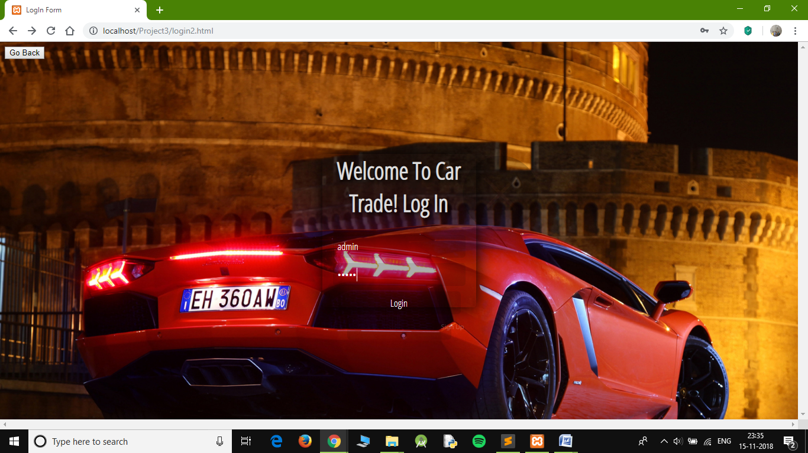

**Fig 8.1 Admin Login**

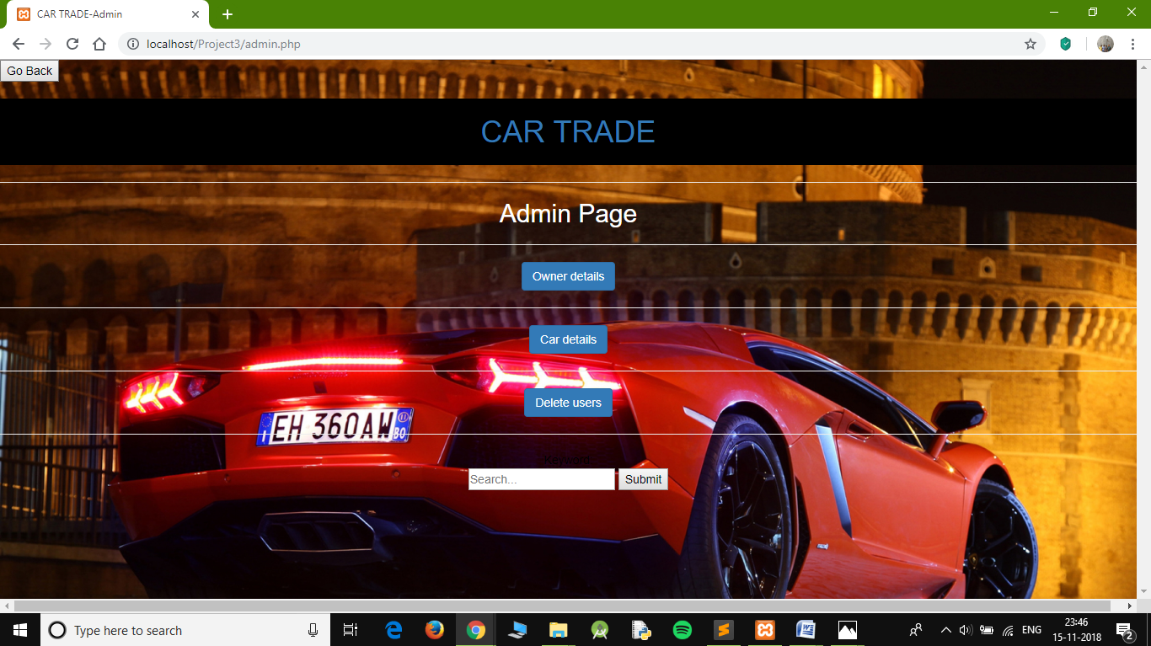

**Fig 8.2 Admin operations**

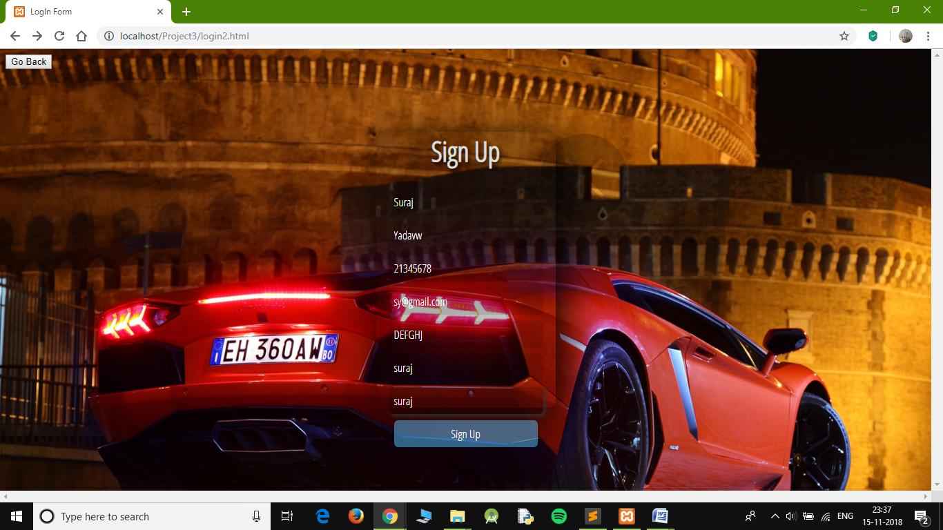

**Fig 8.3 User Signup**

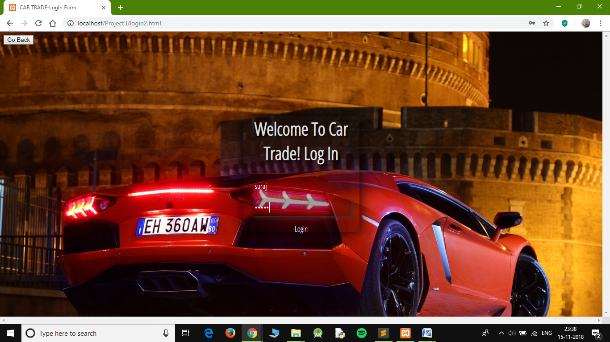

**Fig 8.4 User Login**

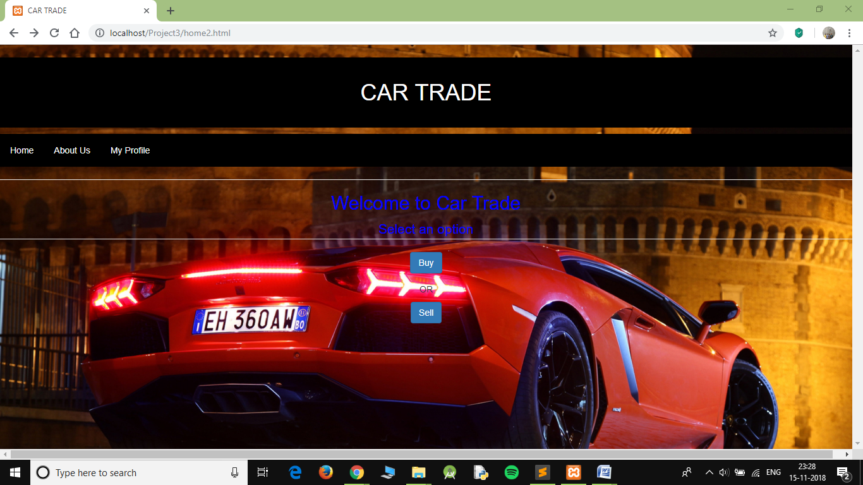

**Fig 8.5 User Signup**

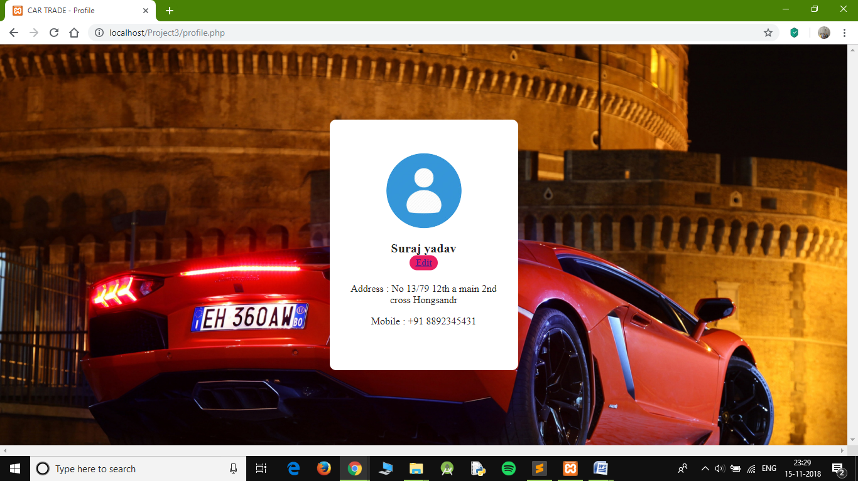

**Fig 8.6 View Profile**

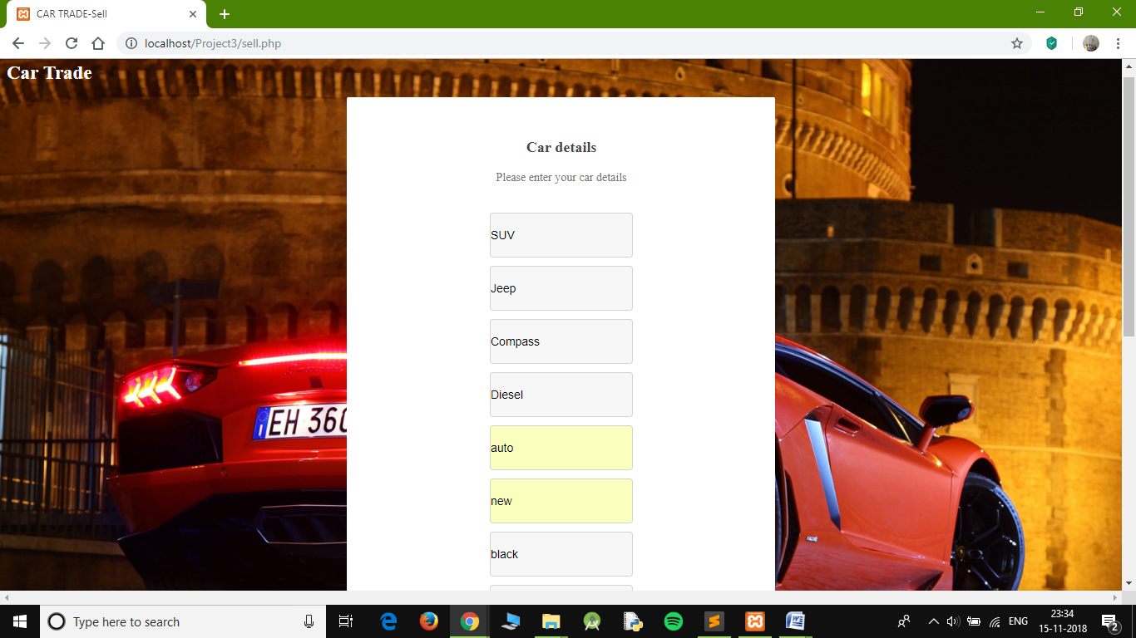

**Fig 8.7 Sell Car**

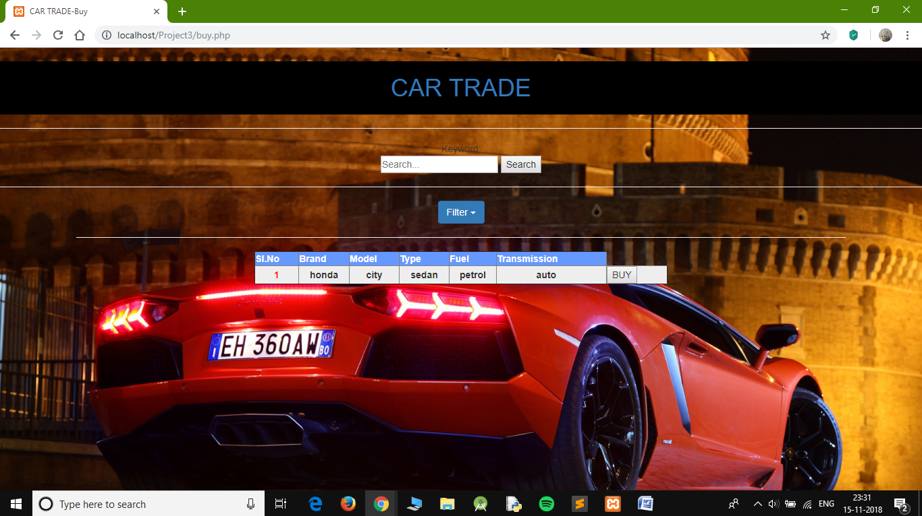

**Fig 8.8 Buy Car**

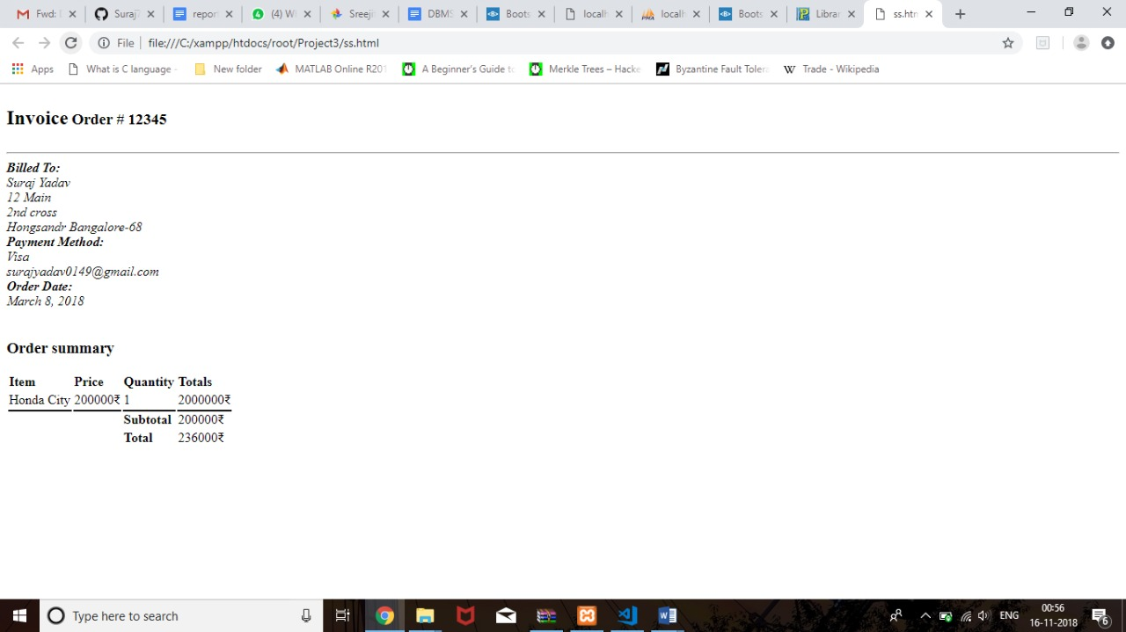

**Fig 8.9 Generated Invoice**

**Chapter 8**

**Conclusion**

The successful completion of our project has been a very bright spot for us this semester, as it not only added a great deal of value in terms of technical expertise to our resume but also, it was a rather enjoyable process, learning much about the PHP scripting language, as well as, transaction processing between the frontend and backend systems, and also working with MySQL database using phpMyAdmin administration tool.

Our project is now fully functional and the next step we wish to undertake is to host it as a live website in the near future.

Lastly, we would like to thank our teachers Mrs. Shubha Raj, Mrs. Surbhi and Mrs. Lakshmi for enabling us with the necessary knowledge and guidance required to complete our project and for motivating us to take up this project despite the tight scheduling of deadlines.

**Chapter 9**

**References**

* Support for Frontend : https://www.javatpoint.com , https://www.tutorialspoint.com, https://bootsnipp.com/
* Support for Backend : http://php.net/manual/en/getting-started.php
* Source for Images : https://www.google.co.in
* Support for SQLServer : https://www.w3schools.com , https://www.google.co.in, https://www.phpmyadmin.net/docs/